Exploring College Dataset to Find Insights

QUESTION:2

This exercise involves the Auto data set studied in the lab. Make sure that the missing values have been removed from the data.

(a) Which of the predictors are quantitative, and which are quali-tative?

Code:
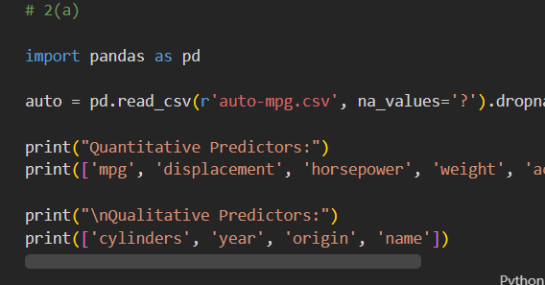
Output:
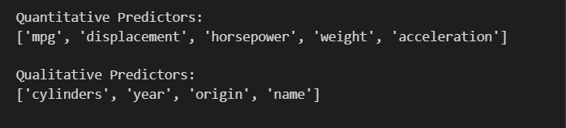
Interpretation:
The quantitative predictors are mpg, cylinders, displacement, horsepower, weight, acceleration, year, and origin, while name is the qualitative predictor.

(b) What is the range of each quantitative predictor? You can an-swer this using the min() and max() methods in numpy. .min()

Code:
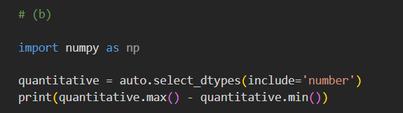
Output:
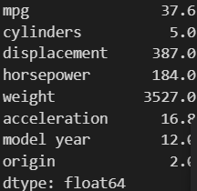
Interpretation:
The range of each quantitative predictor is determined by calculating the difference between its maximum and minimum values.

(c) What is the mean and standard deviation of each quantitative .max()predictor?
Code:
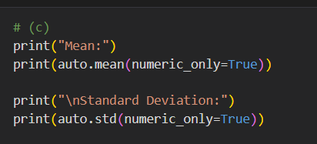
Output:
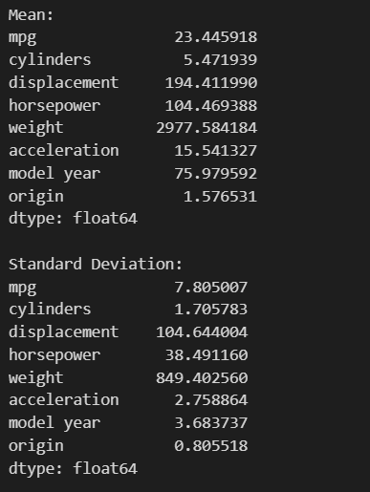

Interpretation:
The mean and standard deviation of each quantitative predictor are calculated to understand its average value and variability.

(d) Now remove the 10th through 85th observations. What is the range, mean, and standard deviation of each predictor in the subset of the data that remains?

Code:
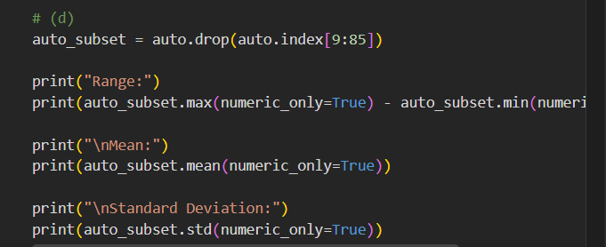
Output:
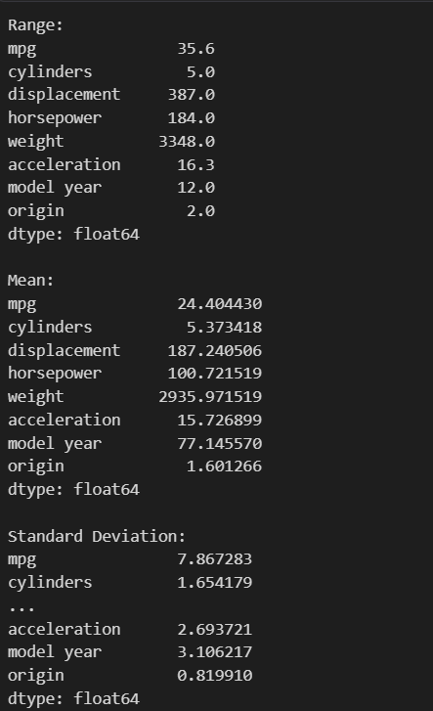
Interpretation:
Removing observations 10 through 85 changes the range, mean, and standard deviation of each quantitative predictor in the remaining dataset.
(e) Using the full data set, investigate the predictors graphically, using scatterplots or other tools of your choice. Create some plots highlighting the relationships among the predictors. Comment on your findings.

Code:
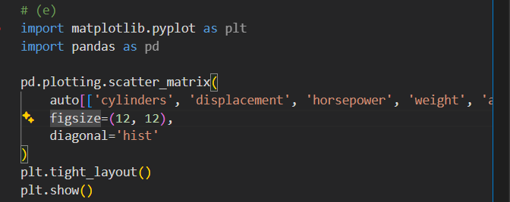
Output:
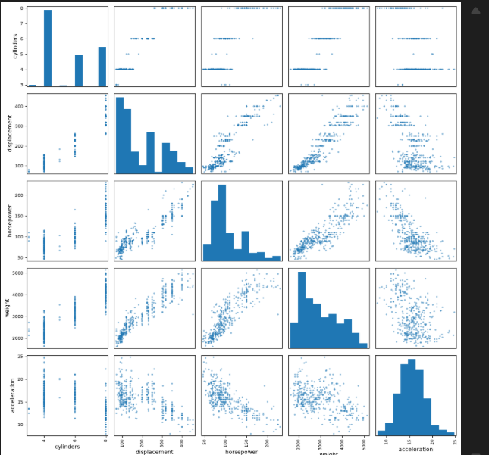
Interpretation:
The scatterplot matrix shows strong relationships among predictors, with weight, displacement, horsepower, and cylinders positively correlated, while mpg is negatively correlated with them.

(f) Suppose that we wish to predict gas mileage (mpg) on the basis of the other variables. Do your plots suggest that any of the other variables might be useful in predicting mpg? Justify your
answer.

Code:
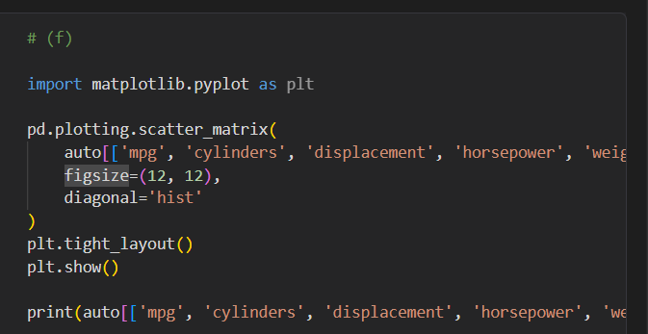
Output:
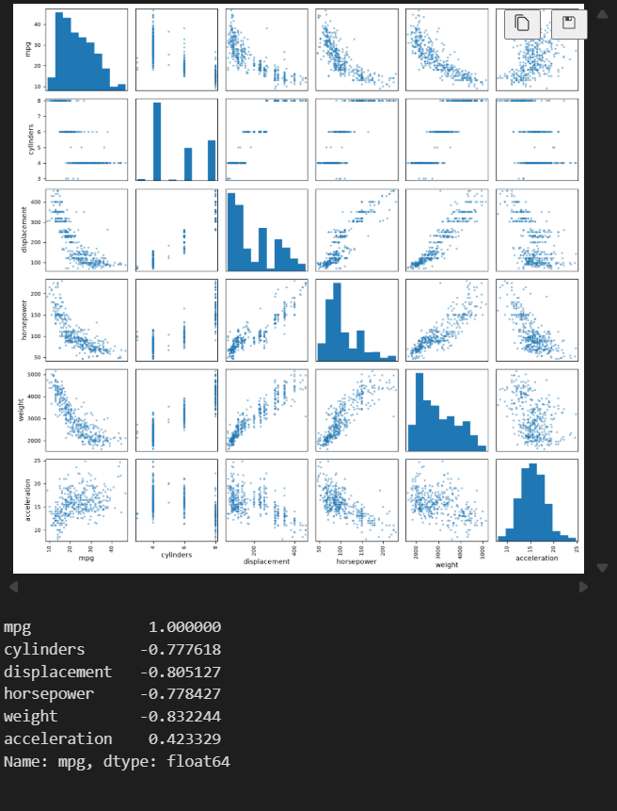
Interpretation:
Displacement, horsepower, weight, and cylinders are useful predictors of mpg because they show strong negative relationships with gas mileage.

